Ludwig-Maximilians-Universität
Institut für Vorderasiatische Archäologie
Proseminar: Neolithikum
Dozent: Dr. Kai Kaniuth
Referentin: Taska Harnischfeger-Wiley
Datum: 8. Mai 2007

Nahal Oren (Wadi Fallah)
32°42'53"N, 34°58'55"E
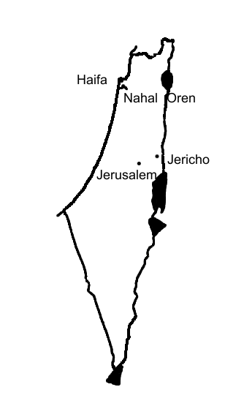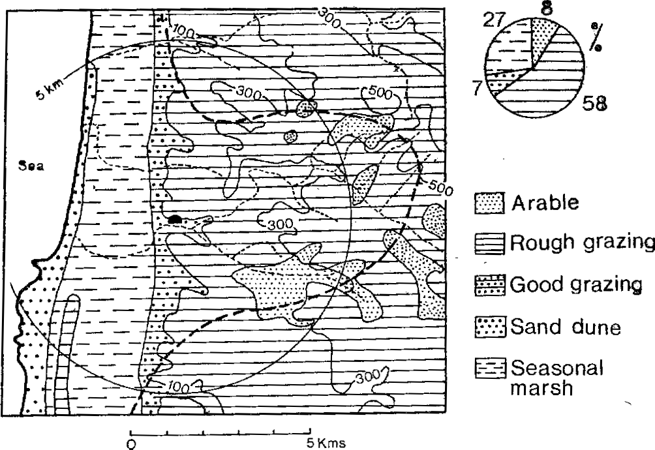

Literatur
Aviram, J. The New Encyclopedia of Archaeological Excavations in the Holy Land (1993) “Nahal Oren” 1166-1170

Noy, T., Legge, A. J., Higgs, E. S. Recent Excavations at Nahal Oren, Israel. Proceedings of the Prehistoric Society, 39 (1973) 75-99
Stekelis, M., Yizraely, T. Excavations at Nahal Oren, Preliminary Report. Israel Exploration Journal 13 (1963) 1-12
Stekelis, M. Preliminary Report on Soundings in Prehistoric Caves in Palestine. Bulletin of the American Schools of Oriental Research 86 (1942) 2-10

Moore, A.M.T. The Neolithic of the Levant (1978) 99-106, 218-221
Roaf, M. Cultural Atlas of Mesopotamia and the Ancient Near East (1990) 25-35
Bar-Yosef, O. The Natufian Culture in the Levant, Threshold to the Origins of Agriculture. Evolutionary Anthropology 6 (1998) 159-177
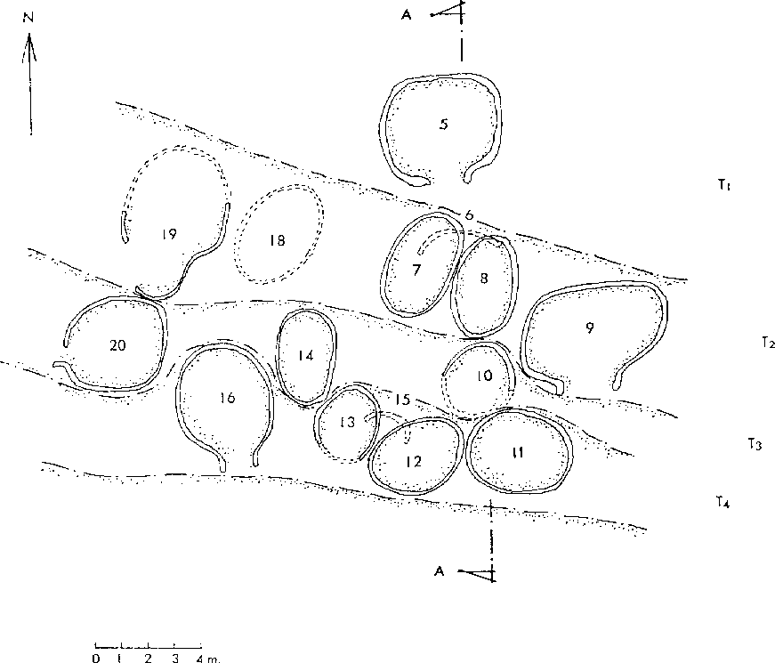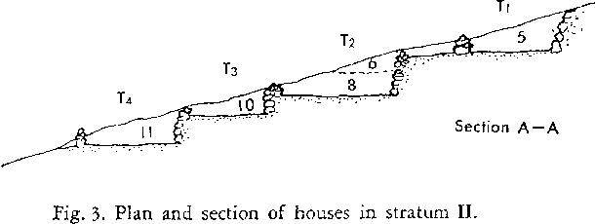
Nahal Oren Stratum II, 1954 – 1960

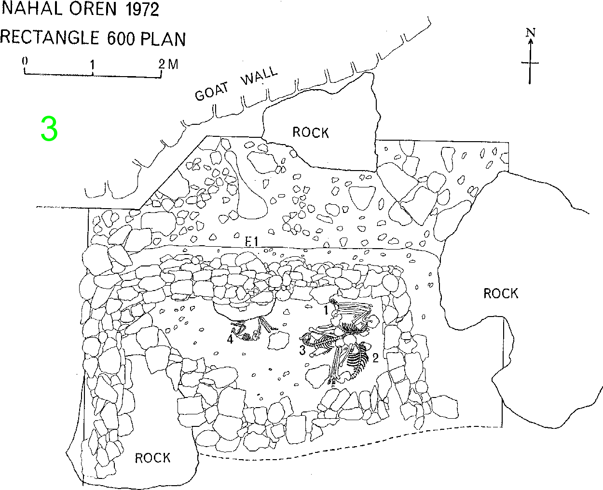
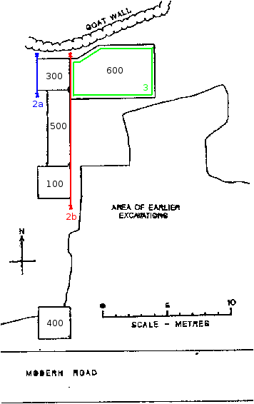
Ausgrabungsgeschichte

1942 Dr. Moshe Stekelis
Hebrew University of Jerusalem
Höhle (Natufian)

1954 – 1960 Dr. Moshe Stekelis,
Tamar Yisraeli (Noy)
Hebrew University, Israel Museum
Abhang

Kebaran (Sondagen)
Natufian Untere Phase
Natufian Obere Phase
“Nahal Oren Stratum I” (PPN)
“Nahal Oren Stratum II” (PPN)

1969 – 1970 Dr. Tamar (Yisraeli) Noy
Dr. Eric S. Higgs
Israel Museum, University of Cambridge, British Museum
Abhang

Schichte IX-VII: Kebaran
VI-V: Natufian
IV?-I: PPN

